# Group Project Proposal – 3DAE

With this document you submit a “Group Project Proposal” for the 3rd year. It’s important that you take your time to fill in the proposal in detail. Based on the info and the quality of the document, we decide with the module managers whether your project qualifies for a group project.

You send the “Group Project Proposal” document, together with a working prototype build, to Alex Vanden Abeele via e-mail ([alex.vanden.abeele@howest.be](mailto:alex.vanden.abeele@howest.be)) before **01/09/2023 08:30**. On September 5th you’ll pitch this project before a jury. Afterwards you will be notified if your group project is accepted or not.

If you have any questions regarding this proposal do not hesitate to ask Alex. **Do not assume things, make sure you’re sure.**

Success in writing your Group Project Proposal!

## Students that participate in this proposal

*List here the students that participated on this proposal. Only students that really collaborated on the proposal can be listed here, do not list students that you would like to have in your team, that is not accepted.*

*Teams larger than 5 are not accepted either, so do not list more than 5 people here. It’s not needed to list a full 5-member team. If you’re with two people (or alone) that came up with a great idea and you would like to work with a team on that idea, that is perfect (preferred), enter those two names and the other students will be volunteers from 3DAE*

|  |  |
| --- | --- |
| Name | Major |
| Lars Smet | GD |
| Elias Triest | IGP |
| Ruben Verhelst | GGP |
|  |  |
|  |  |

## General description of the project

|  |  |
| --- | --- |
| Project Name | Merkhet’s Decay |
| What kind of project/game is it? | Zombie Slasher |

## Description of the project

*Describe the project in about one page*

## "Merkhet’s Decay" is an immersive first-person zombie slasher that seamlessly blends elements of spellcasting and horror into an exhilarating single-player experience. Take control of Merkhet, the half-son of Thoth, cursed by Osiris to endure endless suffering and decaying vitality. To break this curse, journey through the village, battling hordes of zombies that stand in your path as you strive to reach the tomb of Osiris. As the offspring of Thoth, the deity of time, Merkhet has a unique array of time-manipulating abilities, besides his trusty kopesh sword, to fend off mummies sent by Osiris.

## This innovative fusion of time manipulation and zombie-slaying offers an unprecedented gameplay dynamic that sets "Merket Decay" apart. Set against the backdrop of ancient Egypt's nocturnal landscapes, the game has a mystical ambiance. As darkness shrouds the surroundings, mummies emerge from the shadows to ambush you, providing an adrenaline-fueled experience. The game guarantees non-stop action as you unleash your sword to go through waves of the undead. The real allure lies in the game's distinctive time manipulation capabilities, setting it apart from conventional zombie titles. Harness these four abilities to outmaneuver enemies in unique ways:

## Accelerate mummies' aging process, causing them to decay and perish within seconds.

## Instantaneously teleport to your position from 3 seconds ago.

## Erect a protective dome where time freezes, granting you a precious few seconds to inflict substantial damage, capitalizing on your unfrozen state.

## Execute a rapid dash to enhance your combo potential.

## "Merkhet’s Decay" is designed for solo play on PC, with keyboard and mouse support, while controller compatibility may be added in the future. With its captivating fusion of genres and groundbreaking time manipulation mechanics, "Merkhet’s Decay" offers a captivating adventure for gamers seeking a multi-dimensional zombie slaying experience.

The shader will be realistic, with detailed meshes that are made to fit in a night environment.

## What do you want to achieve with this project?

*Describe what you expect as an acceptable outcome of your project? What kind of result can we expect?*

We wanted to make a zombie slasher with a unique twist, that would really differentiate itself from other games in the genre, so we started digging for unique mechanics or features to use in this kind of game.

After doing lots of research, we stumbled onto the concept of time manipulation in games. Which we found a very interesting mechanic to begin with. After doing further research, we found that this topic was not explored to its potential and we came up with some interesting mechanics and abilities to use in our game, to show the potential of time manipulation mechanics.

Another unique element is the setting, a zombie game situated in Egypt, combined with parts of the mythology of the ancient Egyptians.

Overall we wanted to create a unique combination of out-of-the-box mechanics and a special setting to make a fun, unique high-paced zombie slasher.

## What are your plans with the project once it is done?

*Be realistic about this – but we do expect you to have plans with the result. Projects just for fun are nice, but we want to achieve more with these projects. Do you plan to start a company when successful? Do you intend to compete somewhere? Do you intend to sell this game?*

After completing the game project for the class, we would like to showcase the game to peers and instructors, gathering feedback to identify areas of improvement. The goal isn't to start a company, although the experience gained could lead to future collaborations or personal projects. If people enjoy the game, we can enter competitions like the rookies, we are also planning to publish it on steam if there is interest in our game.

## What technology do you plan to use?

*Describe the software and hardware you intend to use and whether you have access to everything you need.*

Software: Maya, Visual Studio, Unity, Blender, Substance Painter, Substance Designer, Photoshop, Perforce…

Hardware: our PC’s, to play: PC, Keyboard, mouse, drawing tablet

## On what platform do you want to release and via which store front?

*We intend to achieve this – be realistic.*

On PC. We will release the game on Itch.io, and also promote it on our own portfolios. If the game is successful and receives good feedback, we would be interested to release it on Steam.

## What is the target audience?

*Make sure this is well defined. “For everyone from 7 till 77” is not accepted, this range is too broad. Motivate your choice.*

Age: 18+. We target people that enjoy zombie slashers and people that like mythology in fighting games. People that appreciate a game with realistic graphics will also be able to appreciate our game. Overall we want to bring new elements to a traditional zombie game, so anyone interested in that, will be interested in our game. We also want to bring in new players, a little less familiar with the zombie slayer genre by adding these special time mechanics with an infinite amount of possible ability combo’s that speak to any curious gamer.

Attachments   
You can add additional info that enhance your project proposal; sketches, mockup, game design, life design, character design, moodboard, ...

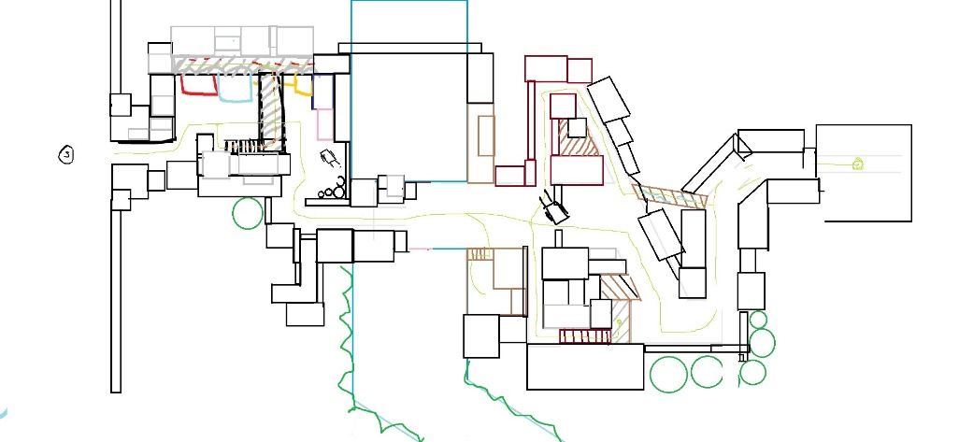

https://sketchfab.com/3d-models/mummy-creature-sculpt-a7d3167b03e043179702b8e16f284c5e

https://sketchfab.com/3d-models/thoth-game-ready-character-928e7020f37e4f7aa72a82bdc1395580

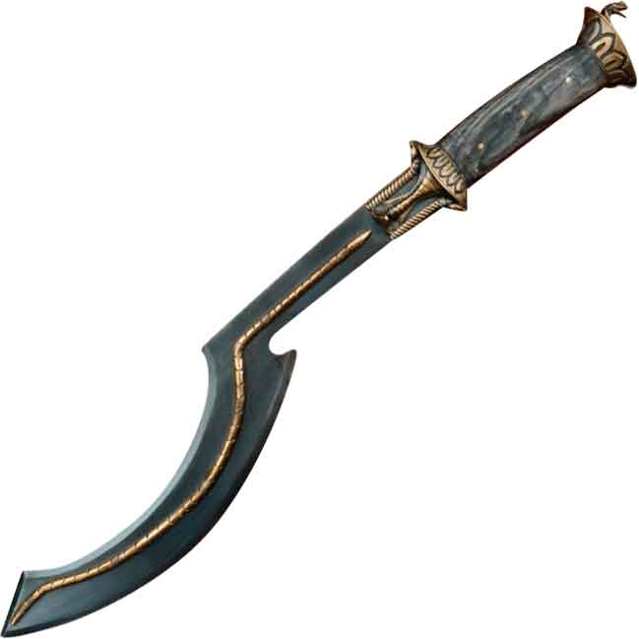

https://www.google.com/url?sa=i&url=https%3A%2F%2Fwww.darkknightarmoury.com%2Fproduct%2Fkhopesh-of-the-pharaoh%2F&psig=AOvVaw2lAntTzqreCwzoEA2Xzrmn&ust=1693623162507000&source=images&cd=vfe&opi=89978449&ved=0CBAQjRxqFwoTCPD-_Ye0iIEDFQAAAAAdAAAAABAE

